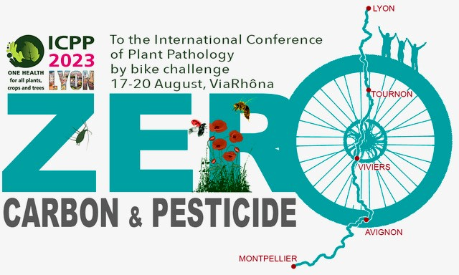

ICPP2023 by Bicycle

#ICPP_by_bike is a collective of about 20 scientists who strongly believe in facilitating biking as a means of personal and professional transportation – at all scales. From our homes and research institutes in Avignon, Montpellier and Bordeaux in France, Milan in Italy, Stratford-upon-Avon in the UK and Columbus, Ohio in the USA we will set out together for the ICPP-2023 conference in Lyon along the ViaRhôna (https://en.viarhona.com/) bike path starting from the legendary Pont Saint Bénezet bridge in Avignon. The main goals of the #ICPP_by_bike collective are to raise awareness about the carbon footprint of our professional and personal activities and to confront a biking challenge that can reveal obstacles to reducing our footprints. These goals are part of growing initiatives concerning environmental and social reasonability of our behaviors as citizens and professionals that include diverse actions ranging from reducing the use of pesticides in agriculture to fostering social and economic justice. To achieve our goal of biking for three days for a total of >250 km together in the August heat of southern France, we have spent several months building a cohesive team founded on a sense of solidarity. We would like to extend this solidarity to scientists qualifying for the ISPP Resilience Bursary. Please donate to the ISPP Resilience bursary in recognition of the kilometers we will pedal. Click the PayPal Button or use the QR Code to Donate

For more information about #ICPP_by_bike contact cindy.morris@inrae.fr

The International Society for Plant Pathology (ISPP) (@Food_Security) established a “Resilience Bursary for Plant Pathologists” in 2022. ISPP contributed to and received funds from other plant pathology Societies and individuals to support emergency/refugee situations, specifically for plant pathologists. Currently the fund has supported about 13 refugee scientists from Ukraine through support for placements in Polish Research Agencies co-ordinated by the Polish Phytopathological Society. We are also liaising with the Turkish Society of Plant Pathology and the Arab Society for Plant Protection and the American Phytopathological Society (APS) Office of International Programs (OIP), to support students affected by the 2023 earthquake in Turkiye and Syria. For more information or questions about donations, contact resilience@isppweb.org. To keep up on news about the ISPP Resilience Bursary, subscribe to the ISPP Newsletter (It’s free) https://www.isppweb.org/newsletters/search_volume.html

